

Aviation Analysis.

Presented by

Mohammed on 25

th

of march in the year 2025

Overview.

•*Analyzing aviation accident trends to improve safety.*

•*Identifying key risks and making data-driven recommendations.*



Business Understanding

•**Stakeholder:** Aviation safety authorities, airline companies.

•**Business Problem:**

Determining which aircraft are the lowest risk for the company to start this new business endeavor. You must then translate your findings into actionable insights that the head of the new aviation division can use to help decide which aircraft to purchase and how can accident data improve aircraft safety?

•**Key Business Questions:**

•What are the most common causes of aviation accidents?

•Which aircraft types have the highest accident rates?

•How do accidents vary across different flight phases?

# Data Understanding

* **Data Source:** Aviation safety under National Transportation Safety Board. **Key Variables:**
* **Date** ( accident data from 1962 to 2023 about civil aviation accidents and selected incidents in the United States and international waters.)
* **Aircraft Type** (What kind of aircraft was involved?)
* **Cause** (What led to the accident?)
* **Phase of Flight** (Takeoff, cruise, landing, etc.)
* **Survival Rate** (How many people survived?)
* **Dataset Size:** X records (to be determined after processing data.

# Data Analysis – Trend Over Time

◆

**Insight:**

Line chart showing accident trends over the years.

◆

**Key Takeaway:**

Are accidents increasing or decreasing?

◆

**Business Impact:**

Helps stakeholders understand risk trends.

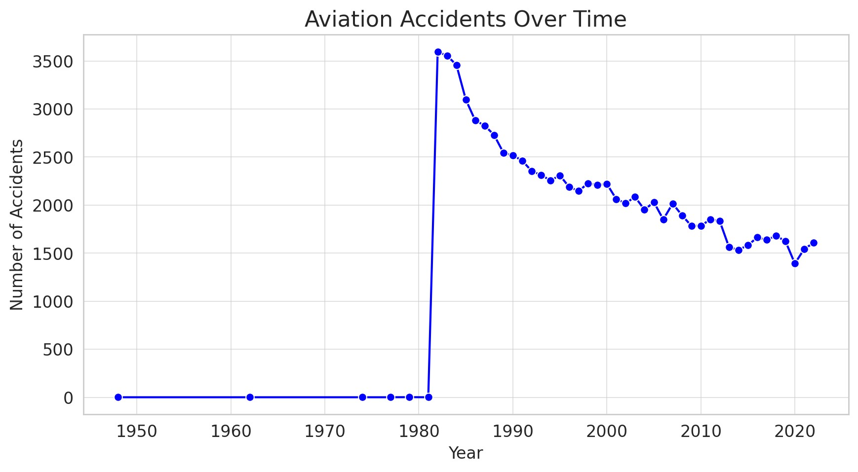

# Data Analysis – Accidents by Aircraft Type

◆

**Visualization:**

Bar chart showing accident distribution across aircraft types.

◆

**Key Takeaway:**

Identify high

-

risk aircraft models.

◆

**Business Impact:**

Helps manufacturers and airlines prioritize safety

improvements.

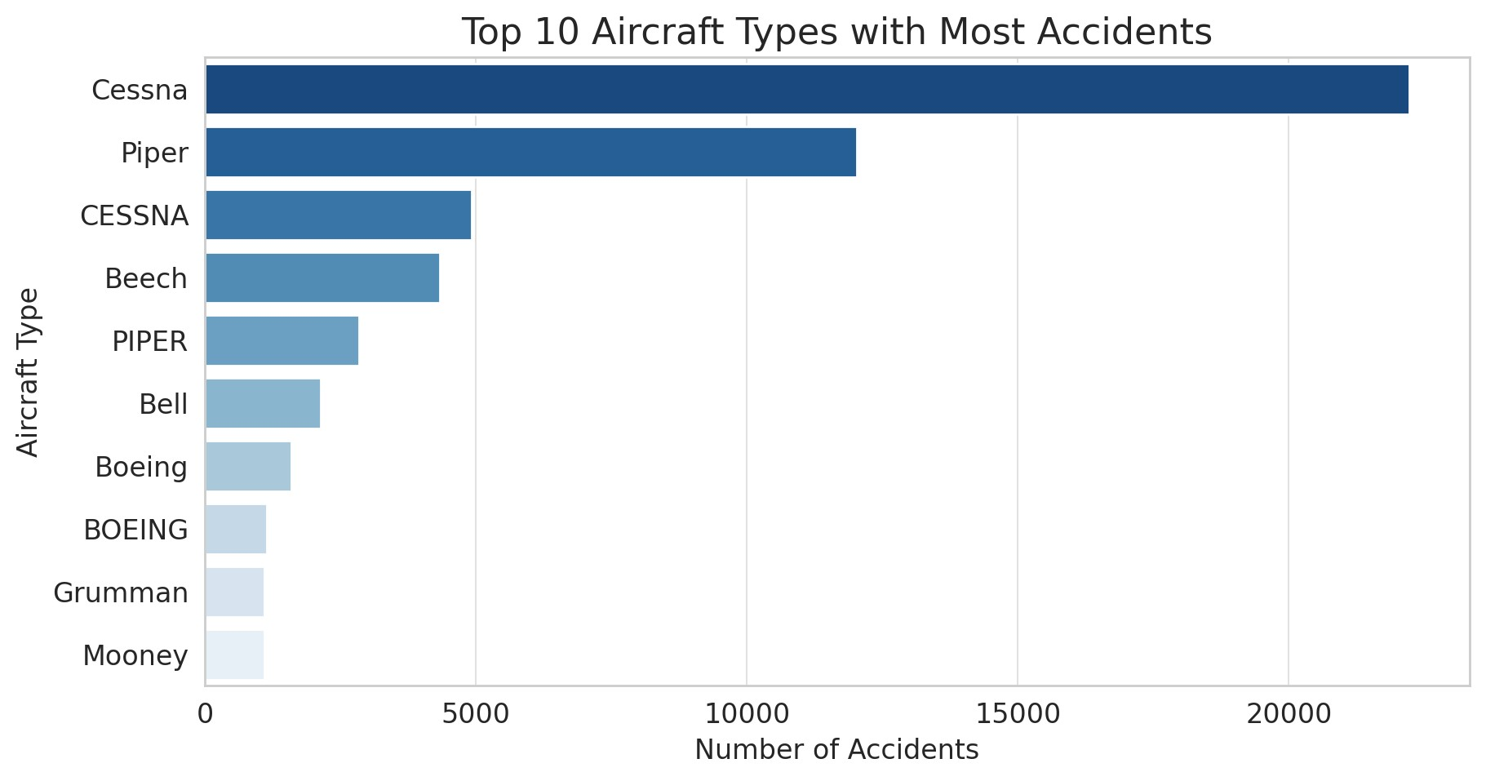

# Data Analysis – Causes & Phase of Flight

◆

**Visualization:**

Pie chart or bar chart of accident causes and flight phases.

◆

**Key Takeaway:**

Determine common accident causes.

◆

**Business Impact:**

Supports proactive risk mitigation strategies.

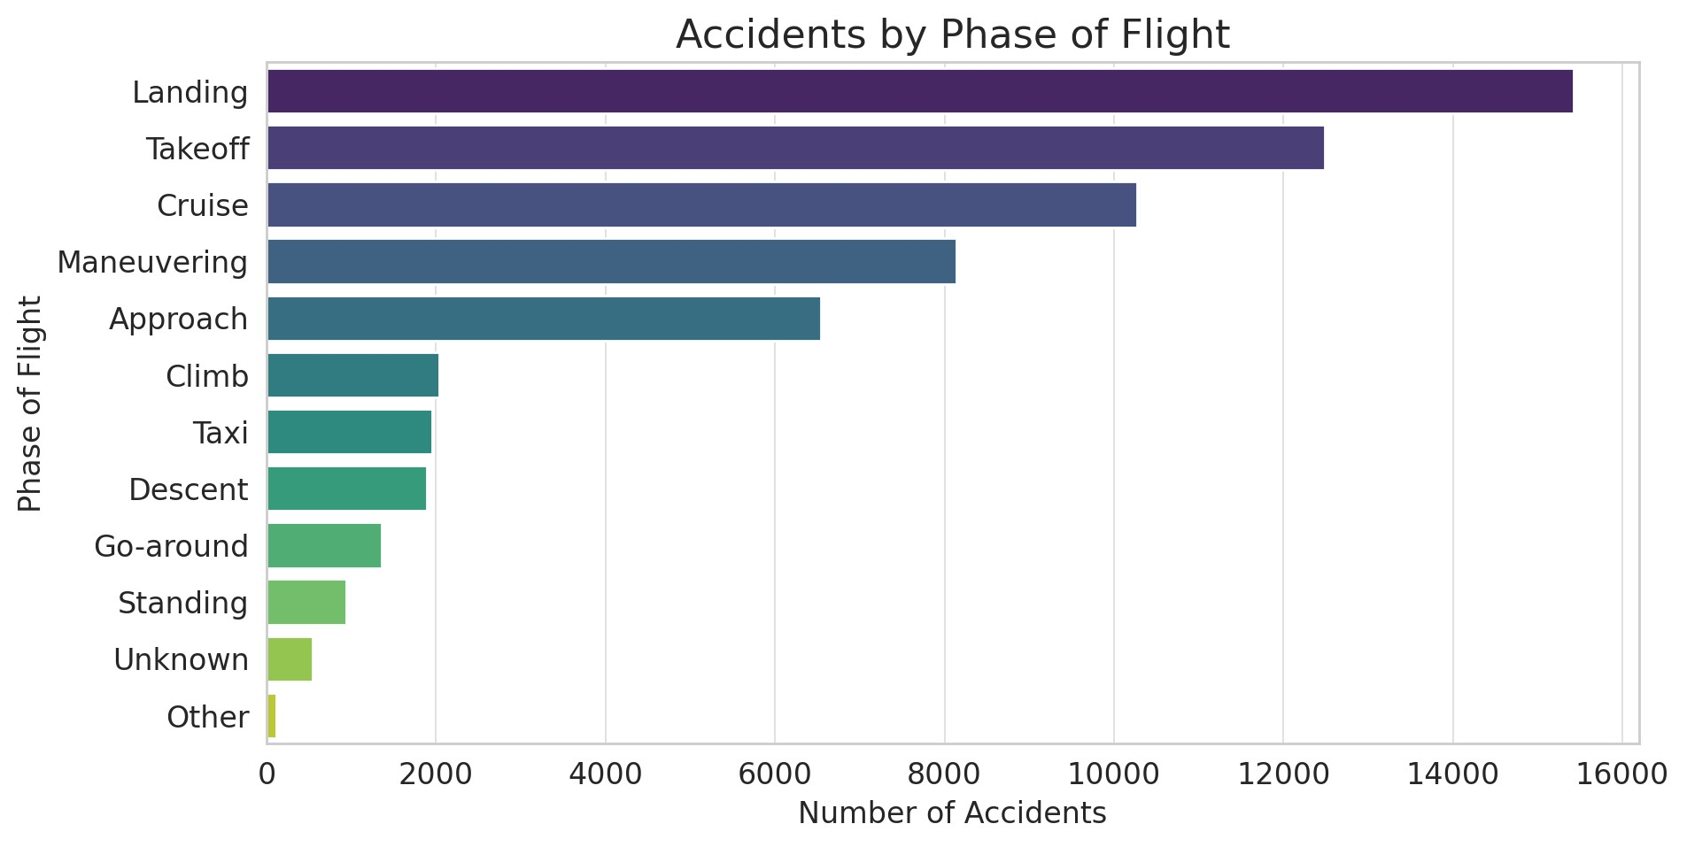

# Recommendations



* **Increase Safety Training:** Focus on high-risk phases of flight.
* **Improve Aircraft Maintenance:** Address most common mechanical failure issues.
* **Enhance Risk Monitoring:** Implement predictive analytics for early warnings.

**Words Of Appreciation**

##  Thank You

Grateful for the trust and opportunity to work on this aviation project. It has been a journey of learning and growth, navigating data challenges and uncovering insights. Every step has been valuable, and I appreciate the support that made this possible.

**Contact:** , Email: Abdimohammedfarhan@gmail.com